Capgemini Big Data and Azure Engineering Batch

Database Fundamentals and SQL programming

Day 4:

Assignments

There is a Product Table like as the following columns and the SalesOrderDetail table.

- Product Table

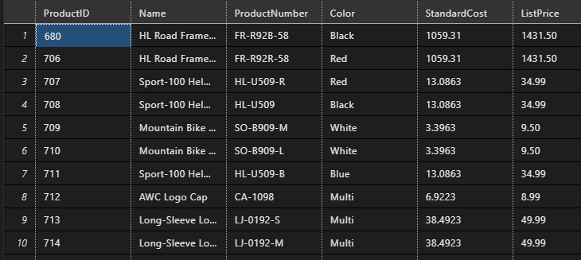

- SalesOrderDetail table

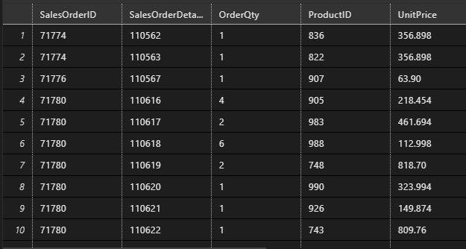

Assignments:

- Write tSQL query to perform INNER join between Product and SalesOrderDetail table
- Write tSQL query to perform FULL OUTER join between the Product and SalesOrderDetails table.
- Write tSQL query to perform LEFT OUTER JOIN to join the Product and SalesOrderDetail table.
- Write tSQL query to execute Right OUTER JOIN to join the Product and SalesOrderDetail table.
- Write a tSQL query to fetch the current datetime from the system.

